606 Fairgrounds Rd.

Warrenton, MO 63383

Administration| 636.456.8935

Fax| 636.456.7764

[www.warrenton-fire.org](http://www.warrenton-fire.org)

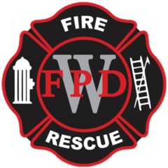

Warrenton Fire Protection District

**NOTICE OF MEETING**

Public notice is hereby given that a meeting of the Board of Directors of the Warrenton Fire Protection District will be held at - **Fire Station No. 2, 26625 S. Highway 47 Warrenton, MO**, Warrenton, Missouri, on Tuesday, April 15, 2025, at 7:00 p.m. to consider and act upon the matters on the following agenda and such other matters as may be presented at the meeting and determined to be appropriate at that time.

**AGENDA**

1. Open Meeting
2. Pledge of Allegiance
3. Approval of Agenda
4. Approval of Previous Minutes
5. Approval of Payment of Bills
6. Review of Treasurer’s Report
7. Financial Report
8. Public Comments

**9) Old Business**

a) April 2025 Election results.

Adjourn Meeting

**New Business**

1) Certify election results

2) Oath of Office

3) Dismissal of past board members

4) Reorganization of the Board Director Seats

5) Committee Reports

Building & Grounds

Equipment & Maintenance

Community Outreach

Planning

Membership

6) IAFF Report

7) Fire Marshal Report

8) Chief’s Report

Adjourn Meeting

The agenda of this meeting will also include a vote to close part of this meeting to the extent it relates to the following: Pursuant to Section(s) 610.021(3).

Dated April 11th, 2025

**Rob Vogelgesang**

Rob Vogelgesang, President – Board of Directors