606 Fairgrounds Rd.
Warrenton, MO 63383
Administration| 636.456.8935
Fax| 636.456.7764
www.warrenton-fire.org

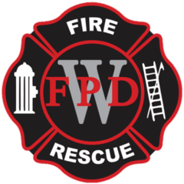
Warrenton Fire Protection District

NOTICE OF MEETING
Public notice is hereby given that a meeting of the Board of Directors of the Warrenton Fire Protection District will be held at - Fire Station No. 2, 26625 S. Highway 47 Warrenton, MO, on Tuesday, January 20, 2026, at 7:00 p.m. to consider and act upon the matters on the following agenda and such other matters as may be presented at the meeting and determined to be appropriate at that time.

AGENDA
- Open Meeting
- Pledge of Allegiance
- Approval of Agenda
  - Consent Agenda
    - Approval of Previous Minutes
    - Approval of Payment of Bills
    - Review/acceptance of Treasurer’s Report
    - Committee Reports
      - Building & Grounds
      - Equipment & Maintenance
      - Community Outreach
      - Planning
      - Membership
    - IAFF Report
    - Fire Marshal Report
    - Chief’s Report
- Financial Report- Presented by Rick Rognan
- Public Comments
- Old Business Items
  - Lager’s Resolution for contribution change
  - Turnout gear
- New Business Items
  - TAL Payoff
  - Plumbing
  - Epoxy Flooring
  - Dumpster enclosure
- Adjournment

The tentative agenda of this meeting may also include a vote to close part of this meeting to the extent it relates to the following: Pursuant to Section(s) 610.021(1-24).

Dated January 16th, 2026

Rob Vogelgesang
Rob Vogelgesang, President – Board of Directors

