606 Fairgrounds Rd.

Warrenton, MO 63383

Administration| 636.456.8935

Fax| 636.456.7764

[www.warrenton-fire.org](http://www.warrenton-fire.org)

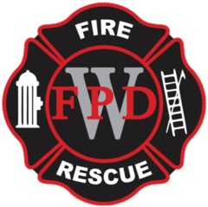

Warrenton Fire Protection District

**NOTICE OF MEETING**

Public notice is hereby given that a meeting of the Board of Directors of the Warrenton Fire Protection District will be held at - **Fire Station No. 2, 26625 S. Highway 47 Warrenton, MO**, Warrenton, Missouri, on Tuesday, May 20, 2025, at 7:00 p.m. to consider and act upon the matters on the following agenda and such other matters as may be presented at the meeting and determined to be appropriate at that time.

**AGENDA**

1. Open Meeting
2. Pledge of Allegiance
3. Approval of Agenda
4. Approval of Previous Minutes
5. Approval of Payment of Bills
6. Review of Treasurer’s Report
7. Financial Report- Presented by Rick Rognan
8. Public Comments
9. Old Business
   1. Medical Insurance Renewal-Scott Robson
10. Adjourn-Sine die

The tentative agenda of this meeting may also include a vote to close part of this meeting to the extent it relates to the following: Pursuant to Section(s) 610.021(1-24).

Dated May 16th, 2025

**Rob Vogelgesang**

Rob Vogelgesang, President – Board of Directors